

Computer Fundamentals

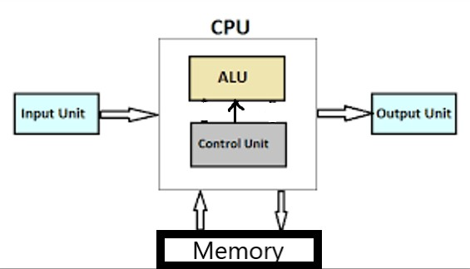

Block diagram of computer

Block diagram of computer



* 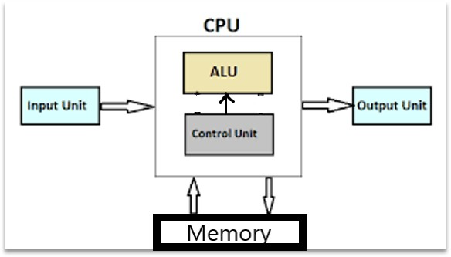CPU : Central Processing Unit
* ALU : Arithmetic and Logic Unit
* CU : Control Unit

# Interaction between CPU ,memory and input/output devices





Interaction between CPU,memory and input/output devices



* Input device input data into computer like data entry through keyboard.
* Data is then processed by the central processing unit(CPU).
* Random access memory (RAM) is used for processing.
* information is displayed through the output device, like on monitor.
* Data and information can be stored in computer’s memory called secondary memory, like on hard disk.
* Secondary memory of computer includes hard disk, compact disk(CD), digital versatile disk(DVD), pendrive ,memory card etc.

Function of CPU and major functional parts of CPU.



* + 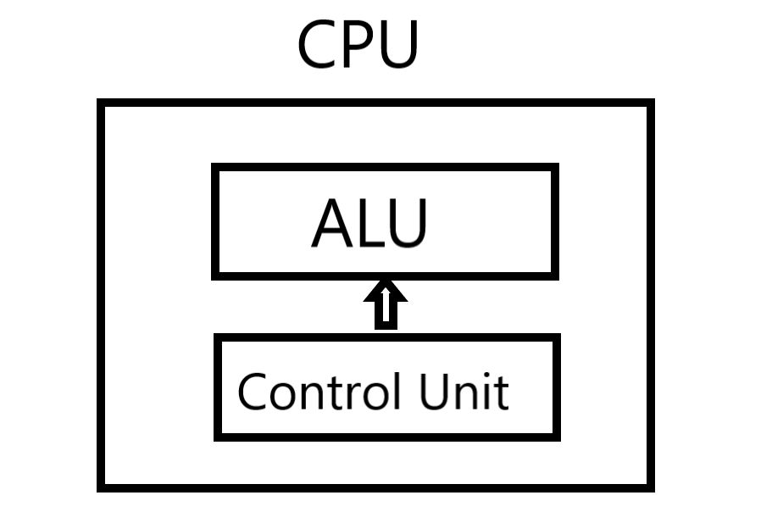CPU : Central Processing Unit
  + ALU : Arithmetic and Logic Unit

# Function of memory



* Computer memory is used for processing data.



* Primary memory processes data.
* When data is input to the computer it is processed according to the program instructions.
* Memory stores data also.
* Like text file, audio file, video file, image file.
* Data is stored on secondary memory. Secondary memory includes harddisk, CD, DVD, pendrive , memory card etc.

# Describe the function of input output devices



* **Input device**
* Input device are used to input data to the computer.
* Keyboard, mouse, scanner, joystick, lightpen ,touchscreen ,optical character recognition (OCR) etc.

# Input device



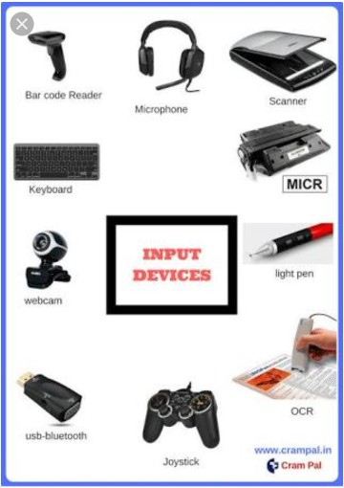

Input device



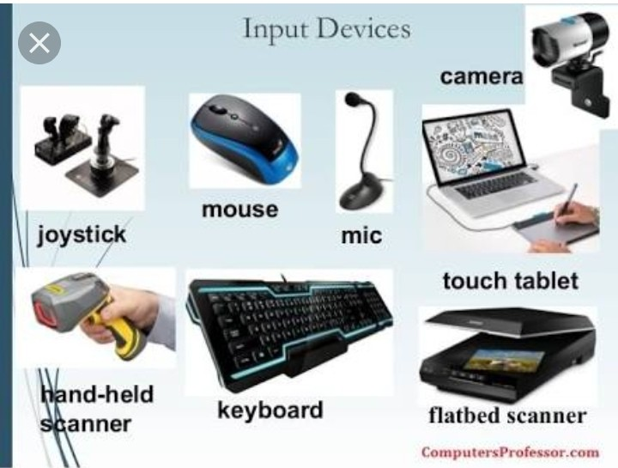

# Output device



* + Output device are used to display data.
  + E.g. Monitor , printer , plotter.
  + There are two broad categories of the output from computers
  + Soft copy
  + Hard copy

# Output device



Output device



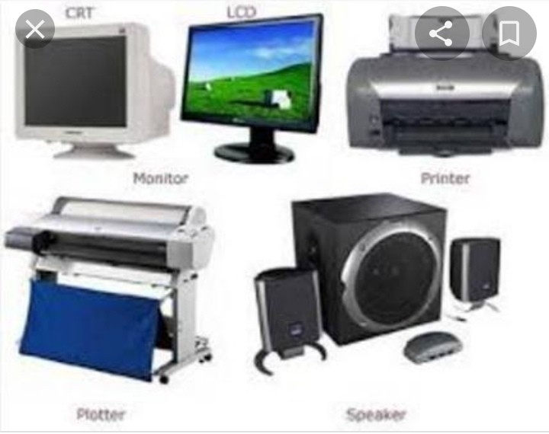

# Relevance of speed and word length for CPU performance



## Wordlength

* Wordlength is the number of bits a CPU can process simultaneously. For example a 32 bit processor is faster than that of 16 bit processor.

## Speed

* Speed refers to the clock speed of the processor.

## Relevance of speed and word length for CPU performance

* The computer with more processor clock speed and word length has higher performance than the computer with less wordlength and processor clock speed.